**Aim : To Configure and Install OwnCloud**

**Steps:**

**Upgrading and Updating Ubuntu**

$ sudo apt update -y && sudo apt upgrade -y

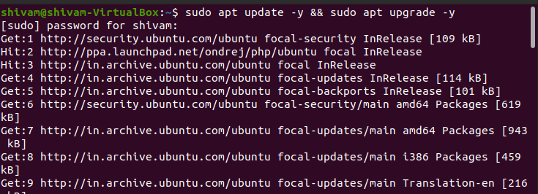

**Installing apache and php**

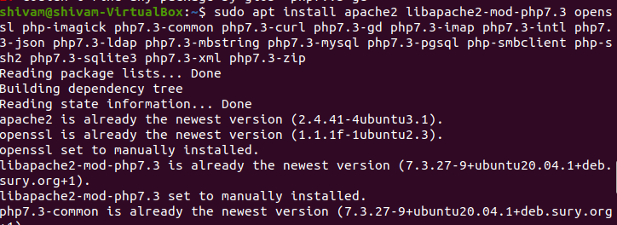

**Checking the installation of apache**

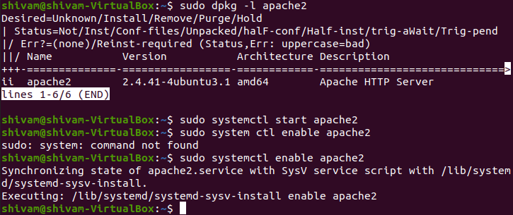

**Checking version of php**

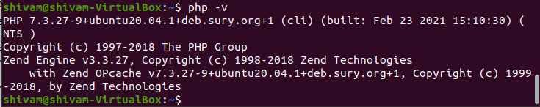

**Installing mariadb server**

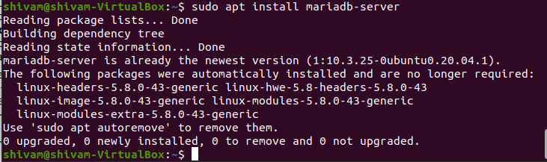

**Securing your mqsql installation**

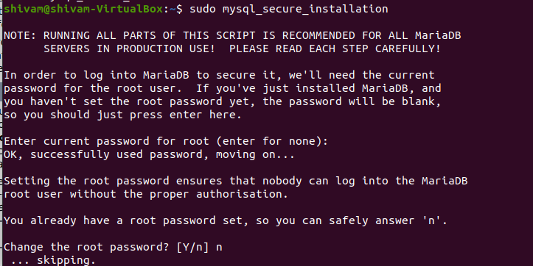

**Creating user and assigning priviliges**

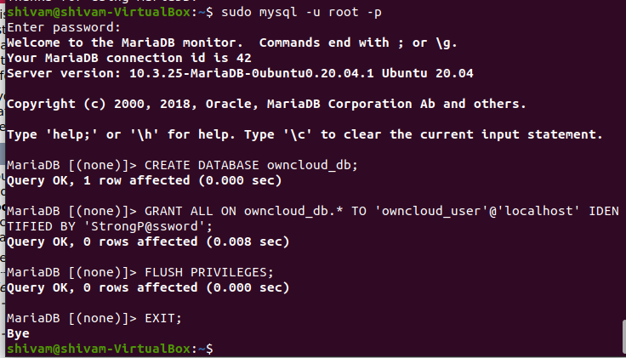

**Downloading and extracting owncloud**

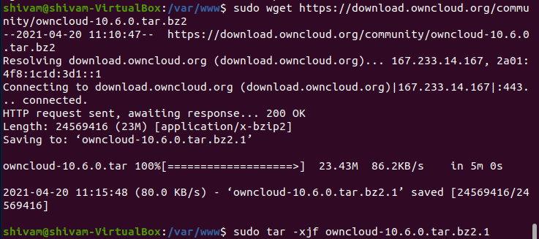

**Changing mode and ownership rights**

**And setting up conf file with the following content**

**Alias /owncloud "/var/www/owncloud/"**

**<Directory /var/www/owncloud/>**

**Options +FollowSymlinks**

**AllowOverride All**

**<IfModule mod_dav.c>**

**Dav off**

**</IfModule>**

**SetEnv HOME /var/www/owncloud**

**SetEnv HTTP_HOME /var/www/owncloud**

**</Directory>**

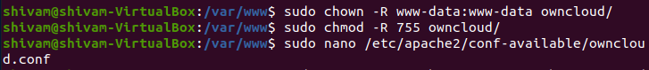

**Enabling services**

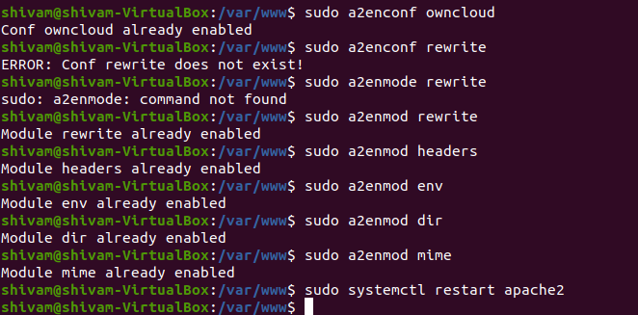

**Running owncloud on apache server**

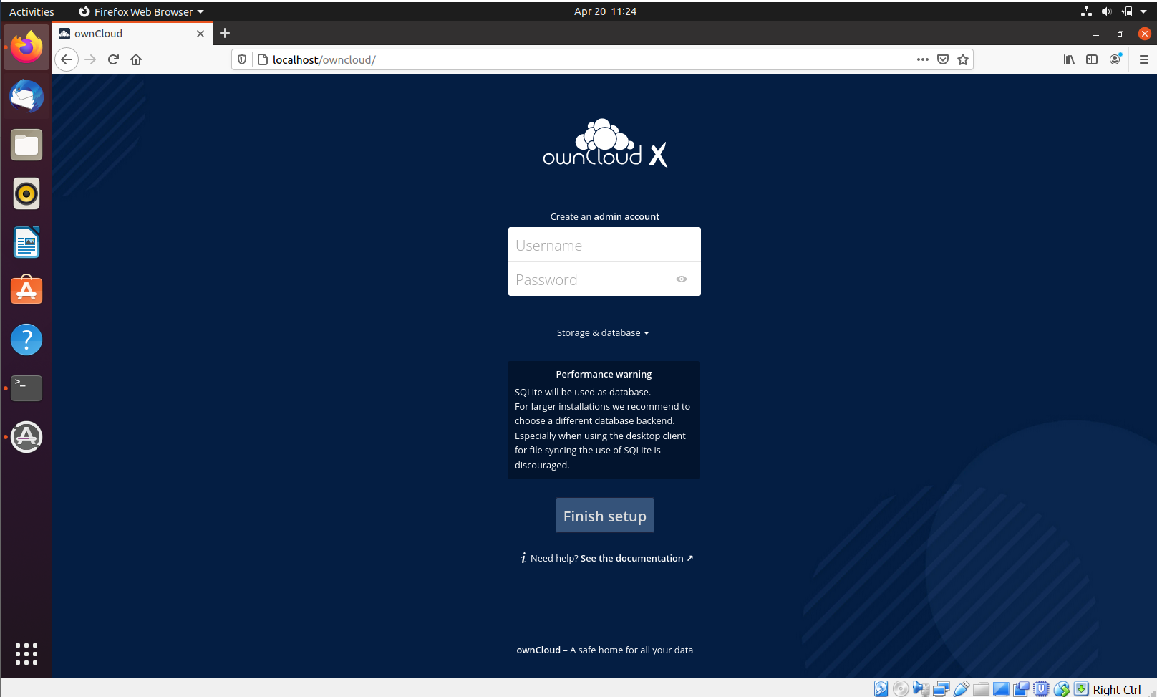

**Setting up admin credentials**

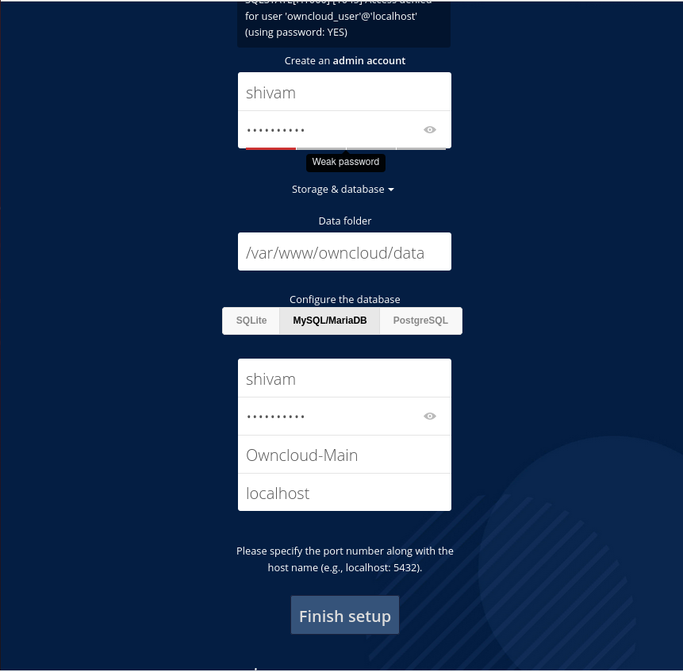

**OWNCLOUD SETUP SUCCESSFULLY DONE**

